**iCommerce Application**

Software Design Specification

**Revision history**

|  |  |  |  |
| --- | --- | --- | --- |
| **Date** | **Version** | **Description of changes** | **Updated by** |
| 11/07/2021 | 1.0 | Version 1.0 | Ngô Xuân Thuấn |
|  |  |  |  |

**Table of Contents**

1 Introduction 5

1.1 Purpose 5

1.2 Scope 5

1.3 Supporting materials 5

1.4 Terms and abbreviations 5

2 System overview 5

2.1 About the application 5

2.2 List of key features 6

2.3 Use case 6

2.3.1 Web console 6

2.3.2 Login/Logout 6

2.3.3 Manage products 7

2.3.4 Manage orders 7

2.3.5 Manage address 8

2.3.6 Online shopping 8

3 Design considerations 9

3.1 Design goals 9

3.2 Assumptions 9

4 Design approach 9

5 Architecture Design 10

5.1 System Overview 10

5.2 System Architecture 11

6 Caching 13

6.1.1 Redis 13

7 Design for authentication 13

7.1 Design for Authentication 13

8 Deployment diagram with kubernetes: 14

8.1.1 CI-CD workflow 14

9 Database design 15

9.1.1 Database ERD 15

9.1.2 Database DDL 16

# Introduction

## Purpose

This document is technical design for ICommerce application. This design focus on instructions that orient to main technical issues need to solve before moving to updating phase. Because the system is implemented already.

## Scope

The scope of the design addresses in details for below items:

* Design considerations
* Architecture design:
  + Architecture, package and class design
  + Database and model

## Supporting materials

The following references are cited in this document

* SRS – Please refer to the latest requirements and function list at TBD

## Terms and abbreviations

|  |  |
| --- | --- |
| Terms & Abbreviations | Details |
| SRS | Software Requirement Specification |
| SDS | Software Design Specification |

# System overview

## About the application

ICommerce is simple online shopping application to sell products. It is a model for providing web developers with a way to link their applications to private backend storage while also providing features such as:

* Product magement
* Orders management
* Address management
* Online shopping

## List of key features

* ICommerce APIs
  + Product magement
  + Orders management
  + Address management
  + Online shopping

## Use case

### Web console

This use case is about web console feature. With this use case

Seller can:

* Login/Logout
* Manage product: add/edit/delete product
* Manage orders: approve, decline orders

Buyer can:

* Login/Logout
* Manage address: add/edit/delete address
* Online shopping

### Login/Logout



### Manage products

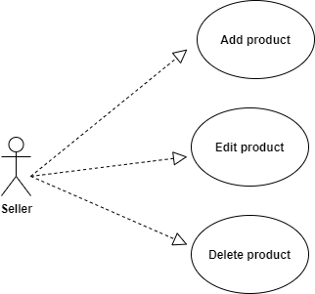

### Manage orders

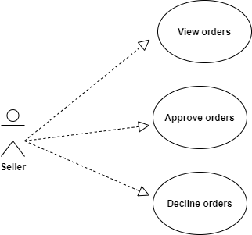

### Manage address

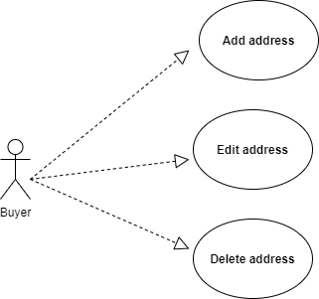

### Online shopping

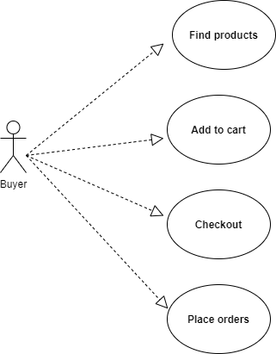

# Design considerations

## Design goals

Service APIs Design:

* The service APIs gives the developer a sense of familiarity and they should not take much time to learn using these APIs.
* The service APIs have to define clearly error code and status response.
* The service APIs must have less than 5 seconds response for each request, the paging should apply for APIs that having too much data response.
* The service APIs must design how to easy in Maintenance and Extensibility
* All APIs request must be authenticated.

Web application:

* The web app gives user easily to use as possible, UI/UX is familiar.
* The web app have to handle multiple concurrents as well.
* All the accessing pages have to be authenticated.
* The web app must design how to easy in Maintenance and Extensibility

## Assumptions

* Back-end APIs are RESTful and returned data is JSON format only.
* Server side technnologies:

Java, MySQL, SpringBoot, Spring cloud and security, JUnit test, Jacoco, SonarQube, Kafka, Redis, Jedis, Swagger, Feign, Lombok, Spring data, Zuul, Maven, Gi, JWT, Hibernate

* Client side technologies:

Angular, typescript, html, css, javascript, jquery

# Design approach

|  |  |
| --- | --- |
| **Goals** | **Strategy** |
| The service APIs gives the developer a sense of familiarity and they should not take much time to learn using these APIs. | APIs should be documented for usage, Interface must be sample designed. Not too much parameters. Error code, response status defined clearly. |
| The service APIs must have less than 5 seconds response for each request. | The paging should apply for APIs that having too much data response. For multiple process should have queue to handle. |
| The service APIs, Web app must design how to easy Maintenance and Extensibility | Code optimization, follow coding standard.  Apply design patterns as possible. |
| Authentication | For all request acces, the system must be verified user Token |

# Architecture Design

## System Overview

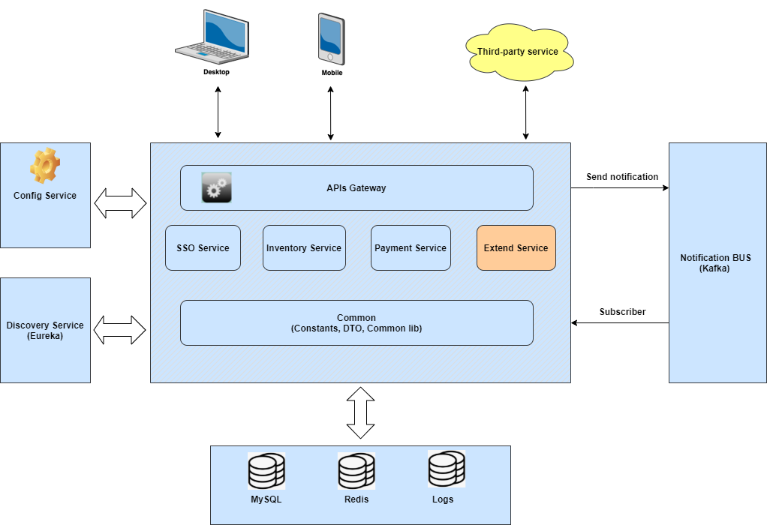

Explanation

* Web: provide web interface to work with authorized API.
* Backend server: The ICommerce server provides APIs Gateway to communicate with mobile and web functions.

## System Architecture

1. Scope of ICommerce
   * Inventory service: all related functions about product information, category information, brand information
   * SSO service: all related functions about user, user address, authenticate
   * Payment service: all related functions about cart, orders
2. Server system architecture  
   * MYSQL: all basic data is saved in MYSQL.
   * Redis: Store token and user information
   * Kafka: Push notification

**Sequence Diagrams**

* **Each function follows MVC pattern in every micro-service**



# Caching

### Redis

Using redis as caching system:

* + Cache user information
  + Cache token information

Using RDM to check data on redis

# Design for authentication

## Design for Authentication

* + All APIs are protected with JWT token.
  + All APIs will be called through token, if User wants to call.
  + All of API in micro-service can not be called directly, they have to through gateway service

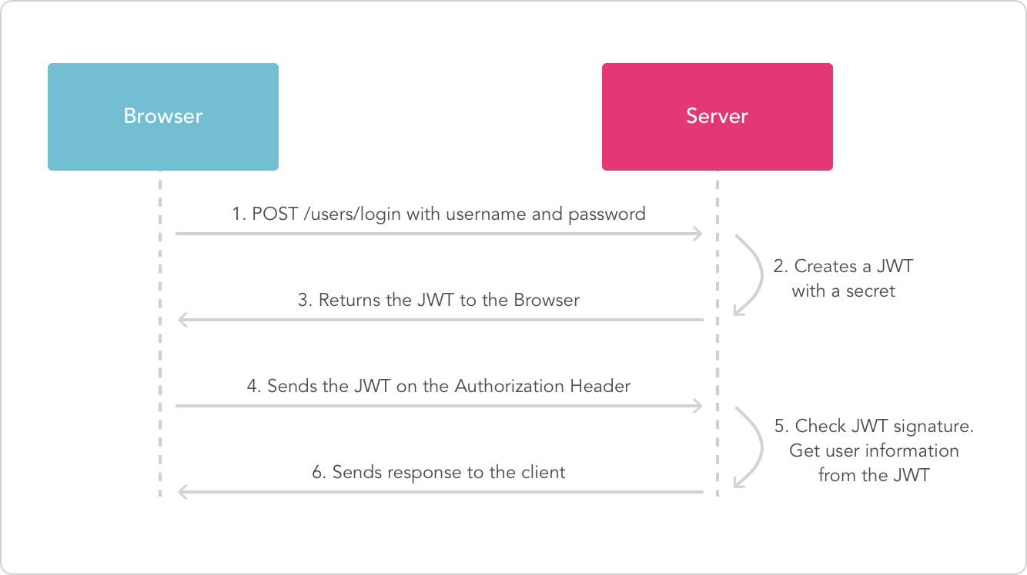

# Deployment diagram with kubernetes:

### CI-CD workflow

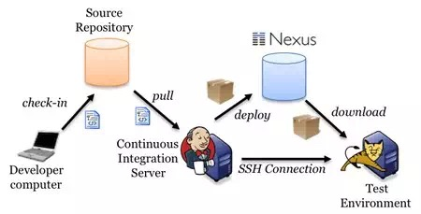

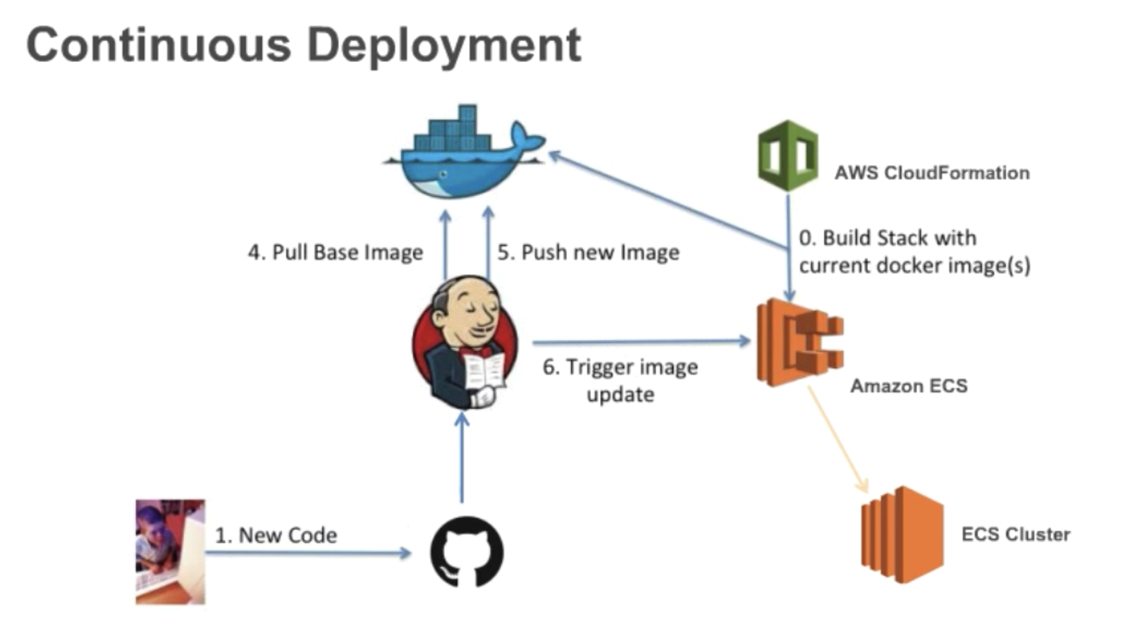

# Database design

### Database ERD

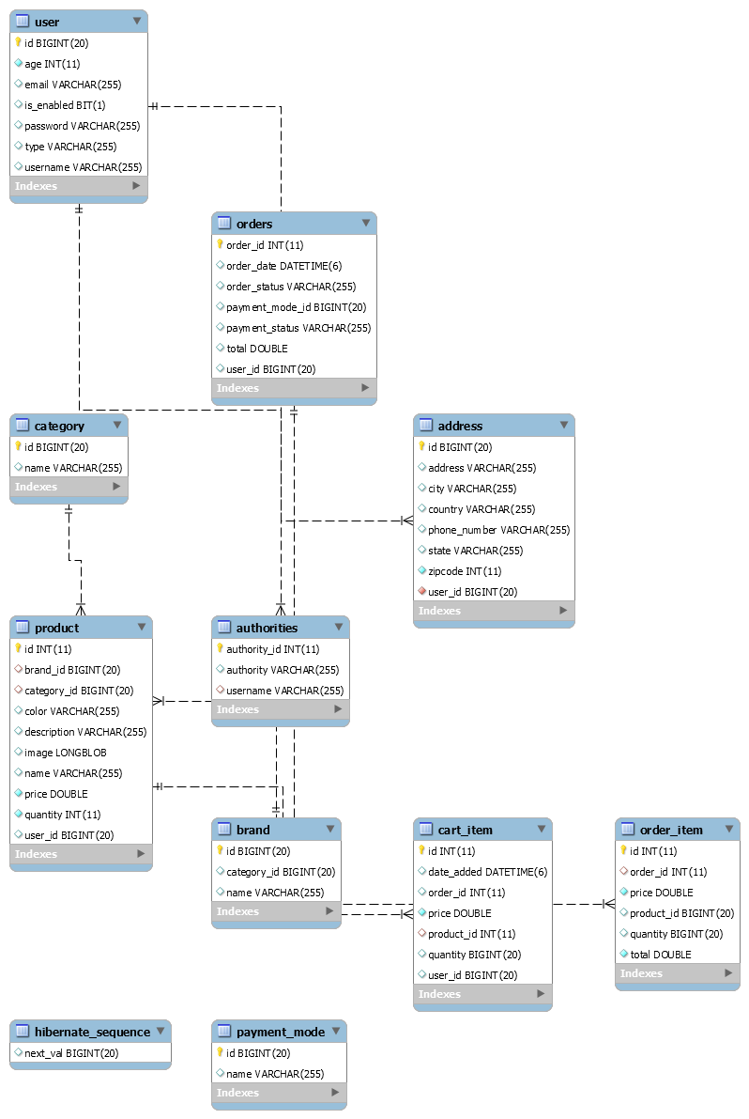

### Database DDL

* + Auto when start service
  + We can user flyway to manage versions